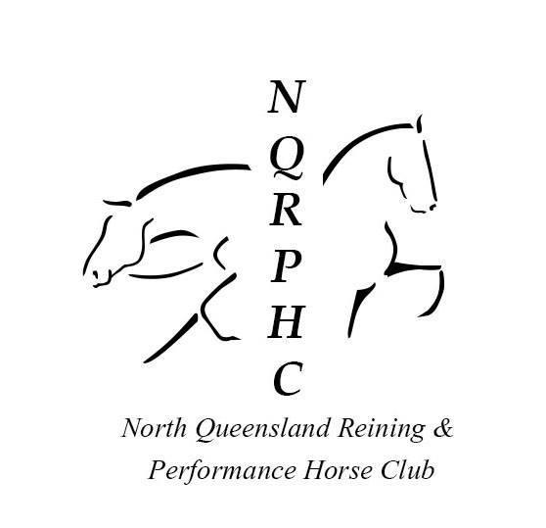

NORTH QUEENSLAND REINING AND PERFORMANCE HORSE CLUB DAY MEMBERSHIP FORM

NAME: _______________________________________________________________________________________
POSTAL ADDRESS: ______________________________________________________________________________
________________________________________________________________ POST CODE: __________________
PHONE: _________________________________ MOBILE: _____________________________________________
EMAIL: _______________________________________________________________________________________
EMERGENCY CONTACT: _________________________________________________________________________

I/we wish to apply for the membership of the North Queensland Reining and Performance Horse Club, and agree to abide by the rules, regulations, policies, procedures as stipulated. I acknowledge that Horse Riding and Participation in horse related activities is dangerous and that accidents causing Death, bodily injury, disability and property damage can and do happen. I acknowledge and agree that neither NQRPHC shall be under any liability for death, bodily injury, loss and damage which may be sustained or incurred by the applicant as a result of participation in or being present at the NQRPHC grounds/events. By signing below I/we give permission for any photos taken on club, training/ show days to be used by NQRPHC in the way of social media and all publicity for the club.
I understand that riding without an appropriate helmet increases the risk of injury in the event of an accident. I choose for myself to ride without riding helmet and I assume full responsibility for this decision.

I acknowledge that I have read and understood the information provided in this membership form.
Signed: __________________________________________ Date: _________________________________
By signing above I/we give permission for any photos taken on club, training/ show days to be used by NQRPHC in the way of social media and all publicity for the club.

