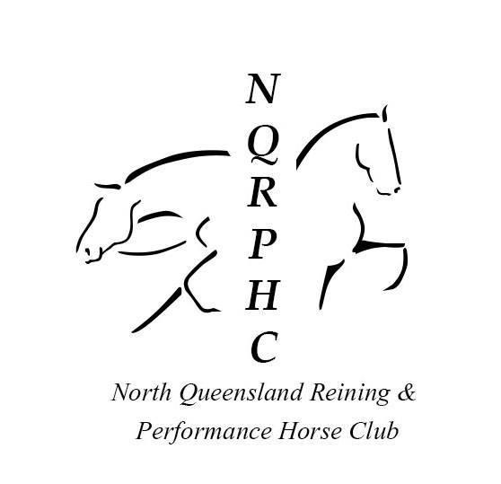
Nomination form do it for dolly
DATE: 31st March 2018
LOCATION: North Queensland Equestrian Centre Forestry Rd Bluewater 4818 PIC NO
PLEASE CIRCLE
Navigation ride $25 Treasure hunt $25 Stick horse $2
Riders Full Name: ________________________________________________________________________
Address: ________________________________________________________________________________
Email: __________________________________________________________________________________
Contact No: ____________________________________
Navigation ride $ ___________Treasure hunt $ ___________ Stick horse $ _________ TOTAL COST $_______

Name | sex | breed | brand | Colour | Pic no
Origin of horse (if different from home address)
Address……………………………………………………………………………………………………………………………….Postcode………………………
Destination details: North Queensland Equestrian Centre Forestry Rd Bluewater 4818 PIC NO
Declaration by owner or person in charge of horse/s attending:
I, …………………………………………………………………………………………………………………………………………………………………………... declare that the horse/s named above has / have been in good health, eating normally and not shown signs of illness during the last 3 days leading up to this event. I give my authorisation for the Event Organising Committee/Manager to call for veterinary inspection of the horse/s named above and in my care should they be showing signs of illness at any time during the course of the event. I agree to pay any veterinary fees incurred for the abovementioned horses as a result of this veterinary examination.
The information contained in this Biosecurity Declaration is true and correct to the best of my knowledge. I agree to abide by all conditions that may be imposed at any time by the Event Organising Committee/Manager. I acknowledge that decontamination and disinfection procedures may be required of me if instructed by the Event Organising Committee/Manager. I acknowledge that there is a possibility that horses might become infected with disease agents as a result of any movements and if necessary horses and premises will be quarantined in accordance with any Legislation covering such occurrences including policies and procedures in effect at that time. I agree and acknowledge that the Manager/Event Organising Committee, it’s State or National Affiliated bodies and their members are not in any way liable for any cost, expense, loss, damage, claim, action, proceeding or other liability incurred by or made against me as a result of any movement of horses to the Event/Farm.
Signature ………………………………………………………………………. DATE ………………………………………………..
INDEMNITY, RELEASE & WAIVER OF LIABILITY
I understand and acknowledge that all aspects of handling, working with and in the vicinity of and riding horses is a dangerous activity and that horses can act in a sudden and unpredictable (changeable) way at any time.
I understand and acknowledge that serious injury or death may result from all activities involving horses.
I agree that I compete and/or attend any show or event conducted or authorized by the North Queensland Reining and Performance Horse Club Inc at my own risk and to indemnify and keep indemnified the organization or person involved in the conduct of any show against all claims, suits, actions or demands which may be brought in respect of any injury or other loss sustained by me in the course of competing/exhibiting at the show and agree to exonerate the committee of management of the show together with any other organization or person involved in the conduct of any NQRPHC event from all loss or injury to me whether due to alleged negligence or otherwise.

Signature………………………………………… Date………………………………..
NB: Parent or Guardian must sign on behalf of Youth competitor.
NAME OF YOUTH:…………………………………………..PARENT/GUARDIAN:NAME: ………………………………………………………… SIGNATURE: ………………………….
©2018 North Queensland Reining and Performance Horse Club inc

